Borja, Ellen Mae J.
BSIT-3C
Activity 4
Exercise 1: Create some links to various search engines.

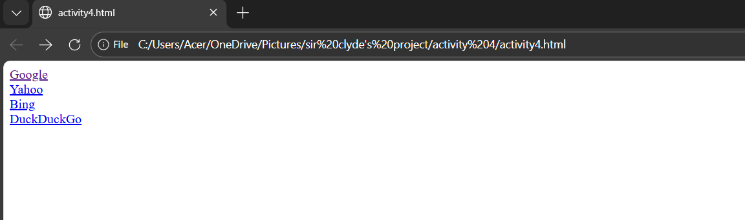
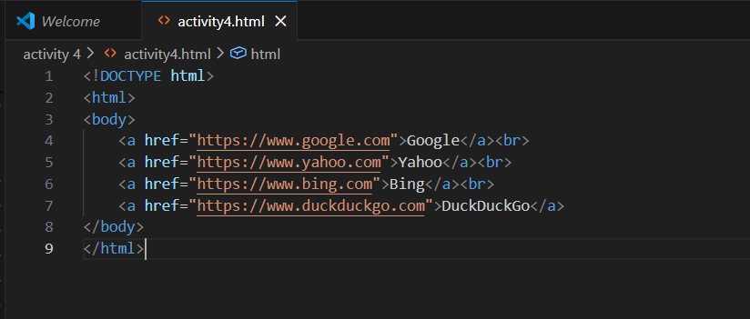

Exercise 2: Create a links to five different pages on five different websites that should all open in a new window.
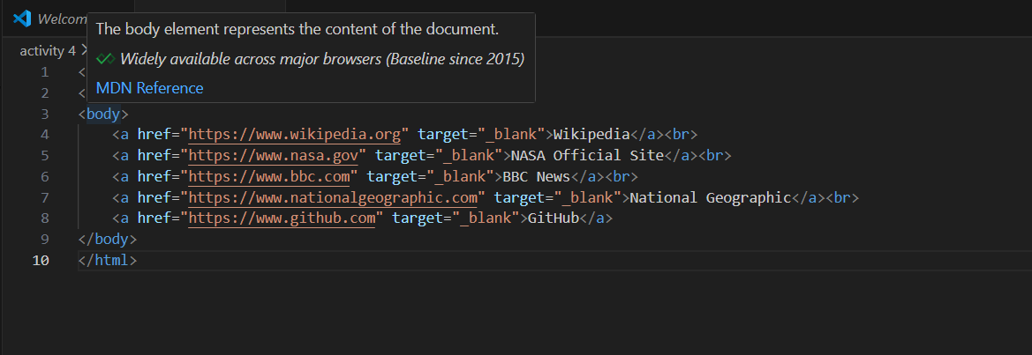
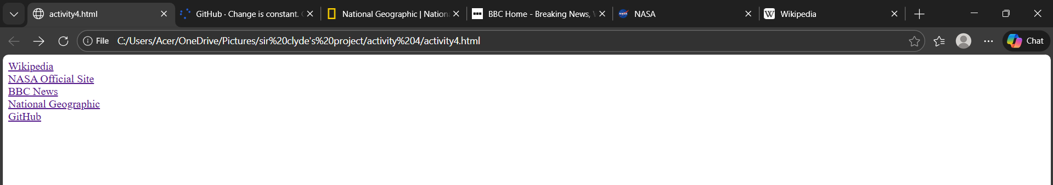

Exercise 3: Create a page with a link at the top of it that when clicked will jump all the way to the bottom of the page.
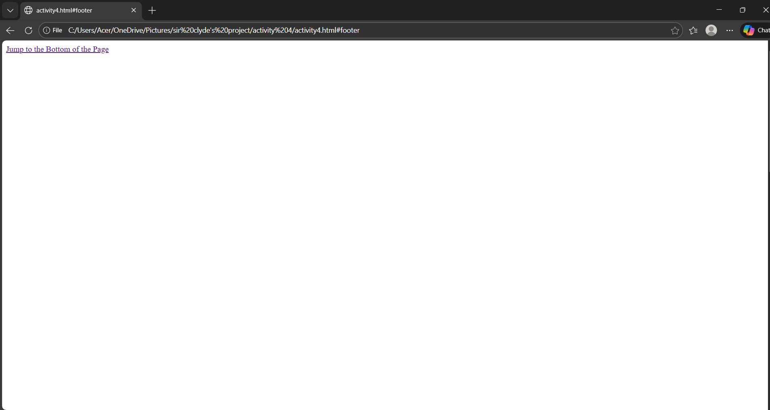
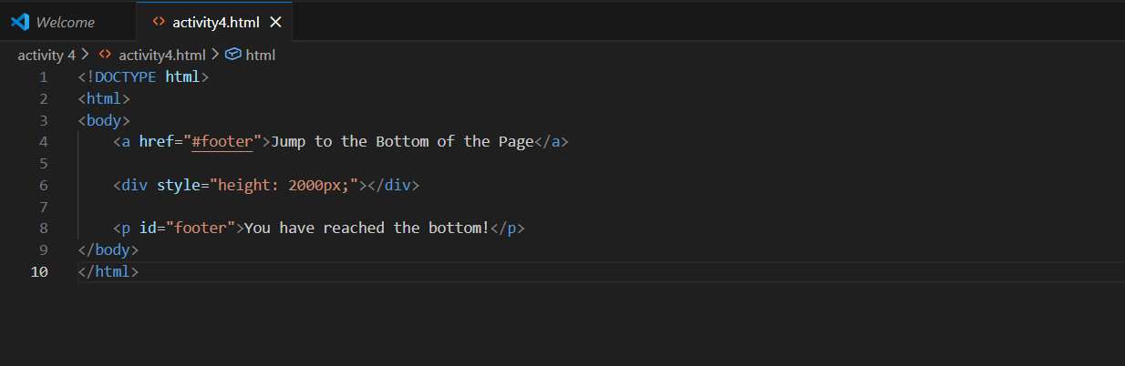
Exercise 4: Create a page with a link at the bottom of it that when clicked will jump all the way to the top of the page.
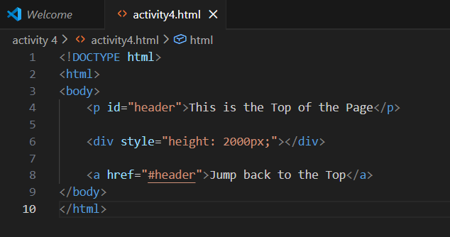



Exercise 5: Create a page with a link at the top of it that when clicked will jump all the way to the bottom of the page. At the bottom of the page there should be a link that when clicked will jump all the way to the top of the page.
